Assignment 2:

1. Please find the below image for the wordcount text file created under /inputs/mr_inputs directory

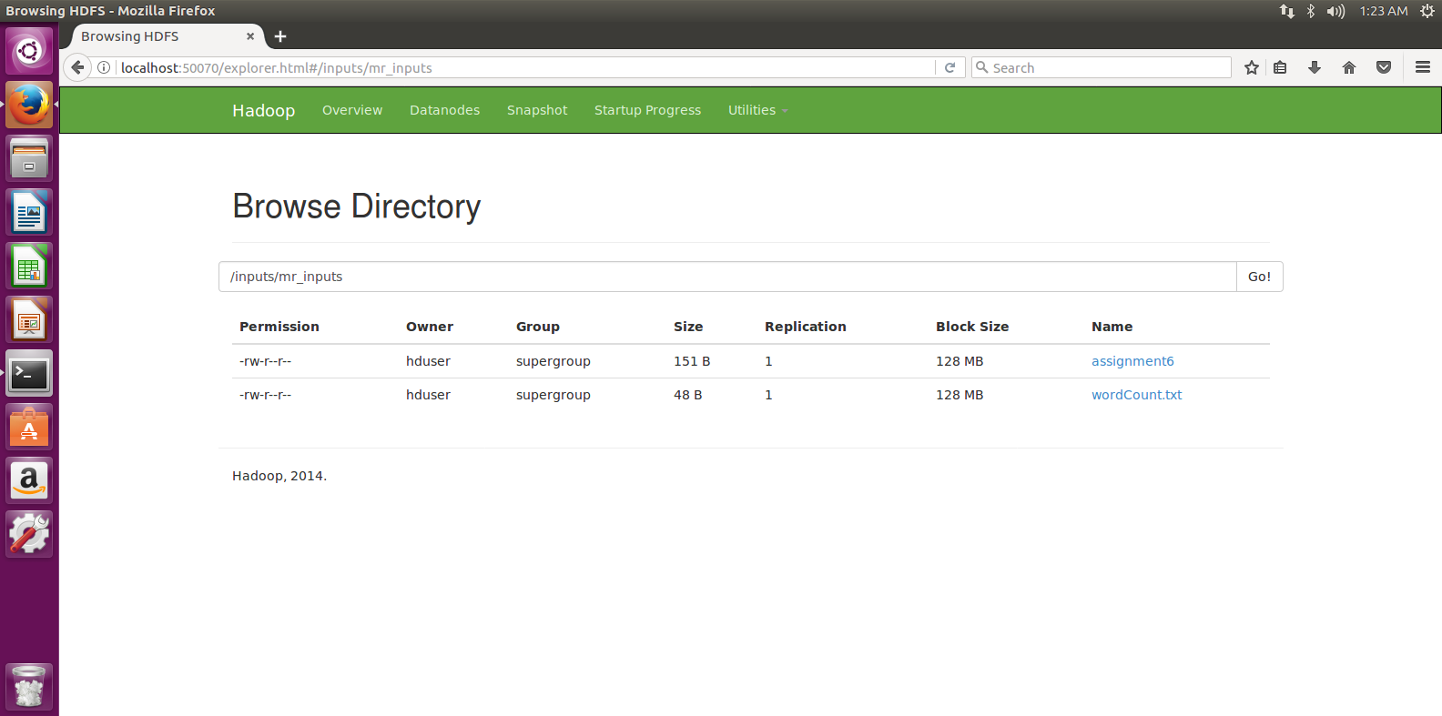

hadoop fs –copyFromLocal wordCount.txt /inputs/mr_inputs/wordCount.txt

hadoop jar /usr/local/hadoop/share/hadoop/mapreduce/hadoop-mapreduce-examples-2.6.1.jar wordcount /inputs/mr_inputs/wordCount.txt /input/mr_output1

Output:

Jack 1

all 1

hi 1

jack 1

jill 1

joe 2

lakshmi 1

maha 2

2.

1.Created a file name wordCount

hadoop jar LineCount.jar /inputs/mr_inputs/wordCount.txt /inputs/mr_output1

Ouput is 4.(no of lines)

2.

hadoop jar RemoveRecord.jar /inputs/mr_inputs/assignment2.txt /inputs/mr_output3

Output is validated:

Only two lines with length greater than 15 are there.